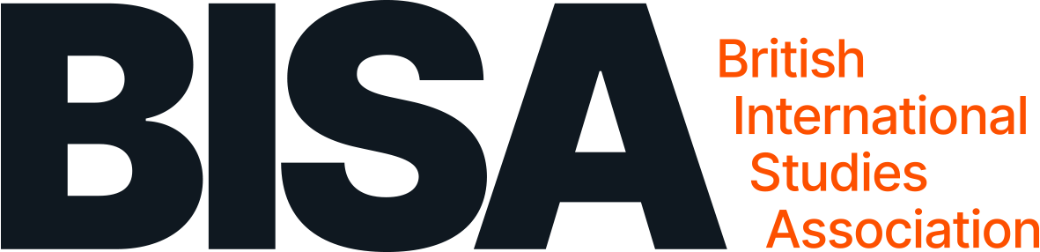

Global Nuclear Order Working Group “Pedagogical Approaches to Nuclear Politics” Friday 15 November 2024, 9.30 – 17.00 GMT (online via Zoom)

Global Nuclear Order Working Group “Pedagogical Approaches to Nuclear Politics” Friday 15 November 2024, 9.30 – 17.00 GMT (online via Zoom)
Zoom registration link: https://indico.bisa.ac.uk/event/467/
The Global Nuclear Order Working Group invites you to a one-day online workshop dedicated to Pedagogical Approaches to Nuclear Politics. This workshop will bring together scholars and practitioners to explore the evolving landscape of nuclear politics education. Through three expert panels, we will cover:
9.30 – 9.45 (GMT) Opening remarks (GNO co-convenors)
9.45 – 11.30 Panel 1: Broader Discussions on Nuclear Governance Patricia Shamai (University of Portsmouth) moderator
Maria Rost Rublee (University of Melbourne)
Laura Considine (University of Leeds)
Jeffrey Michaels (IBEI)
Carmen Wunderlich (University of Duisburg-Essen)
11.30 – 12.15 Break
12.15 – 14.00 Panel 2: Syllabi Status and Innovations
Megan Dee (University of Stirling) moderator
Suzanne Doyle (University of East Anglia)
Nicola Leveringhaus (King’s College London)
Shampa Biswas (Whitman College)/Anne Harrington (Cardiff University) Jana Wattenberg (University of Aberystwyth)
14.00 – 14.15 Break
14.15 – 16.00 Panel 3: Training the Next Generation of Policy Experts
Stephen Herzog (Middlebury Institute/ James Martin Center for Nonproliferation Studies) moderator
Kimberly Peh (Lawrence Livermore National Laboratory)
Rhys Crilley (University of Glasgow)
Rabia Akhtar (University of Lahore)
16.00 – 16.15 Concluding remarks (GNO co-convenors)

